Welcome to Bloom International School
About Bloom Group
Bloom Education Society has established new dimension in the area of Education by establishing a chain of Schools such as Bloom Public School since 1997, Bloom Public Senior Secondary School Ghaziabad since 2001, Bloom Public School Tigri Gate since 2008. Adding International Dimensions to the way of imparting education, Bloom Education Society added another feather to its cap by opening Bloom International School in Greater Noida West(Formerly Noida Extension) in the year 2015.
Bloom International School spread across an area of around 2.5 acres is a fully air conditioned senior secondary school. BIS is affiliated to C.B.S.E. New Delhi till Senior Secondary level with all three streams in Senior Secondary Classes.
Bloom philosophy amalgamates global learning with treasured traditional values of Leadership, Discipline, Academic Excellence and Service. With a complete range of subjects to choose from, a student of BlS is embodied with a unique chance to combine their best strengths towards building a successful career.
What is unique about Bloom International School?
BIS aims to utilize and take full advantage of the CBSE curriculum, by ensuring that pupils get the full range of subjects to choose from. Its unmatched infrastructure, facilities and service towards learning are deemed to make it the best amongst other international schools in Greater Noida West. BIS has a broad vision to make the best out of the talents that students have and nurture them for the service of human race. Bloom International School gives an all-round development environment and facilities that are World Class. It paves way towards every opportunity that every child should be given.BIS gives an international exposure to a student and moulds him/her to take up any challenge in life.
Why choose Bloom International School?
BIS ranks amongst the best Schools in Noida Extension and has proven itself as an unmatched life trainer for young minds. It gives every opportunity that a child deserves and merges all aspects of life to make better people out of the young minds. It believes that education is the most powerful tool to enlighten the society which BIS perceives on a global scale.
MISSION
Bloom International School aims at making the students future ready. We focus on the overall holistic development of their personalities incorporating numerous co-scholastic and extracurricular activities, making them capable of picking the pace of 21st century. We believe education is not limited to teaching but also encourages them to build their own perspective. With innovative teaching styles, we continue to foster children’s intellectual curiosities making learning fun and practical.
IDEOLOGY
Bloom International school focusses on academic excellence and formation of persons with moral uprightness ,social responsibility and pursuit of excellence. The school is committed to ignite the minds of learners to dream big and possess valuable life skills, to impart quality education for promoting intellectualism.

Chairman Message
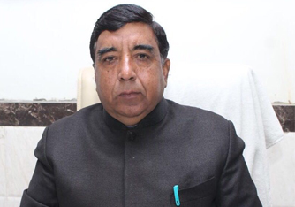 Sh.Yashbir Singh
The purpose of education should be to turn the life of a person into a work of art. The balance of life can be maintained only if it follows the essential principles of rhythm. Our aim is, preparing the students to rise to eminence by developing and utilizing their talents with sincerity, zeal, determination and education. Bloom International School is known for its discipline and achievements.
We are continuously trying our students to be well embellished and aware of the latest technologies in education by providing them cognitive, moral, humane and socio & cultural values to create the ability to determine them self from their within.
We aim at preparing the students to face their nascent mind to explore, understand, learn and appreciate the final aspects of life so that child is able to handle day to day situation without much stress thus giving him a strong and enduring foundation for a successful life.
Principal Message
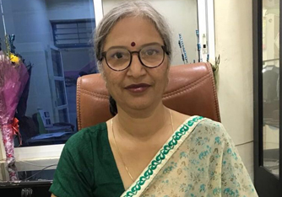
Smt. Shakuntala Rai
The purpose, the aim and drive of our schools, is to equip the child with the most excellent technological proficiency so that the student may function with clarity and efficiency in the modern world. A far more important purpose than this is to create the right climate and environment so that the child may develop fully as a complete human being.There is no right relationship to anything if there is not the right feeling for beauty, a response to nature, to music and art - a highly developed aesthetic sense.
I think it is fairly clear that competitive education and the development of the student in that process are very, very destructive. We must be very clear in ourselves what we want - clear that a human being must be the total human being, not just a technological human being. If we concentrate very much on examinations, on technological information, on making the child clever, proficient in acquiring knowledge while we neglect the other side, then the child will grow up into a one-sided human being. When we talk about a total human being, we mean not only a human being with inward understanding, with a capacity to explore, to examine his or her inward state and the capacity of going beyond it, but also someone who is good in what he does outwardly. The two must go together. That is the real issue in education: to see that when the child leaves the school, he is well established in goodness, both outwardly and inwardly.
I feel that it is important for parents to be aware equally of their children's talents as well as limitations, and allow them to develop in their own way. Our students are our joy and pride. Thank you for entrusting them to our care.
FACILITIES
Physics Lab
The Physics lab is equipped with sufficient apparatus required by students in various experiments and for their extended experimentation in projects. The experiments related to various topics in Physics can be performed from the elementary to the most sophisticated level.

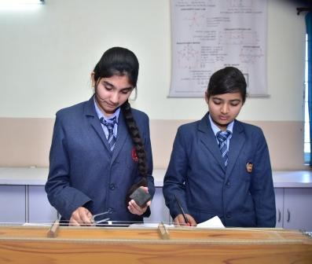

Chemistry Lab
The Chemistry lab is well equipped with apparatus and always has sufficient stock of chemicals to perform various experiments and projects as prescribed in CBSE curriculum. The Chemistry laboratory is designed keeping in mind all the statutory norms and safety standards. It is well ventilated as well as spacious. It has some of the most accurate digital measuring instruments required for measuring chemicals. Separate place for storing chemicals and work tables with acid proof tiles makes it highly safe for the students to perform experiments.

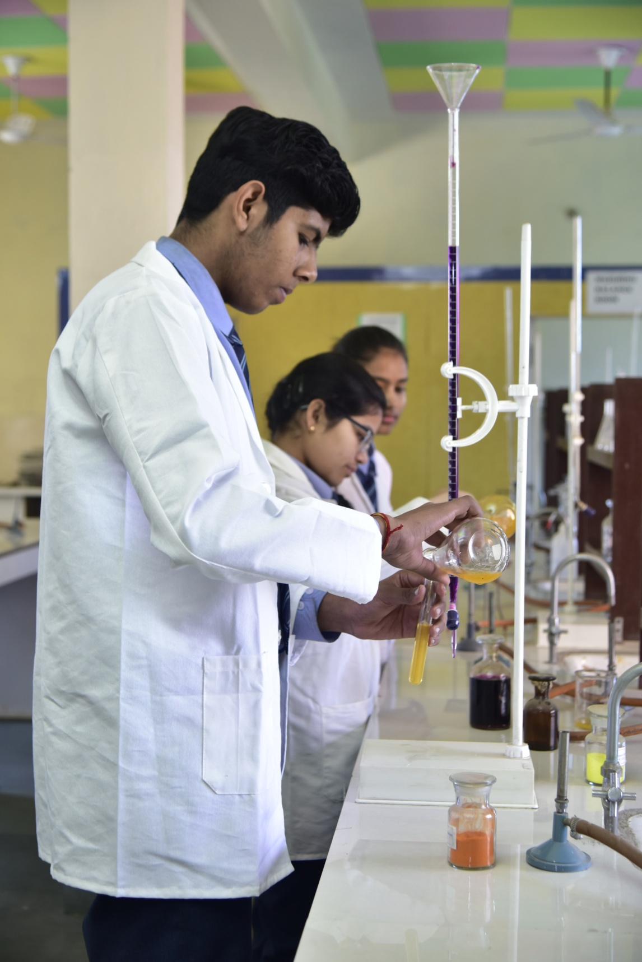

Biology Lab
Biology lab of the school provide all the facilities to the students where they can study their subject with hands on experience. It is well lit and spacious.. Precision instruments, charts and models make learning fun and effective. This is a place where our students are given a chance to ‘discover’ before they are ‘told’. Children have the liberty to make models and projects by availing lab facilities.

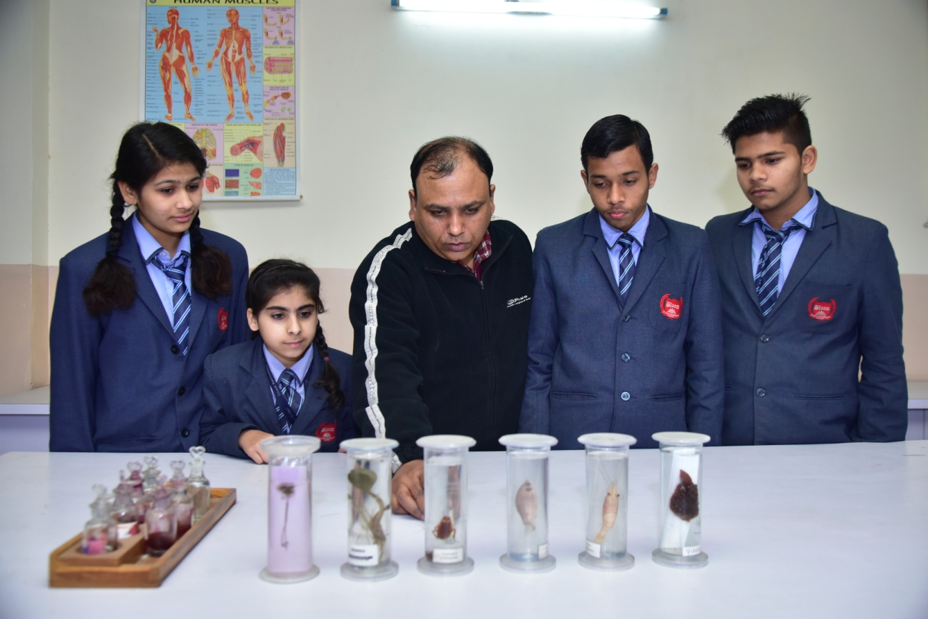
COMPUTER LAB AND AUDIO VISUAL AIDS
Keeping in mind the demand of the IT era, the school has a multimedia lab which includes monitors, LCD projectors for complete awareness. Computer laboratory is fully equipped with latest facilities.
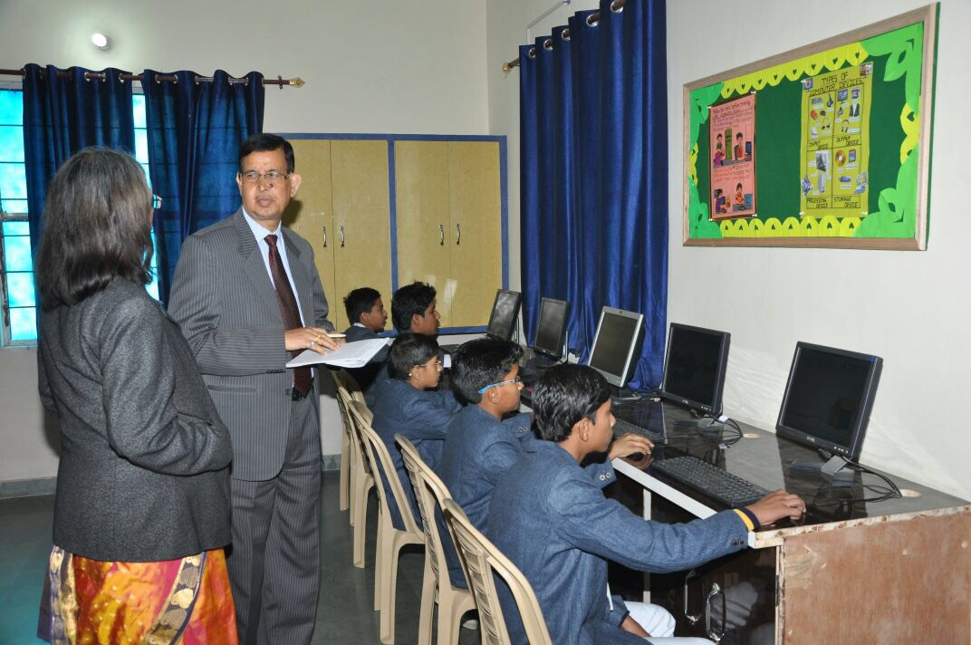

SCHOOL LIBRARY
The School library is a learning resource center in the widest sense as it houses information resources, expansive reading material and digital data with internet access. The library is well stocked with a wide collection of books on a variety of subjects.
The school library fosters the development of life-long learning abilities and love for reading in the students. It also provides teachers with instructional material and professional resources.

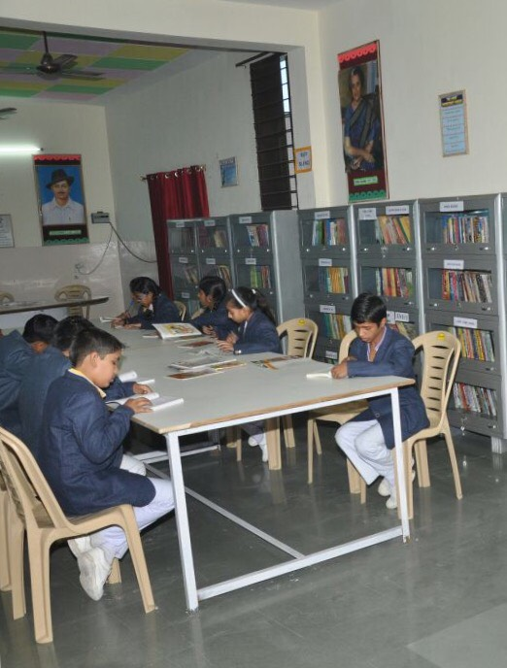
TRANSPORT FACILITIES
The school provides bus facility to Ghaziabad to Noida Extension which is very comfortable and suitable to the requirement of the children. Escorts are placed on duty in every bus. The students have to opt for the bus facility at the beginning of the academic session.
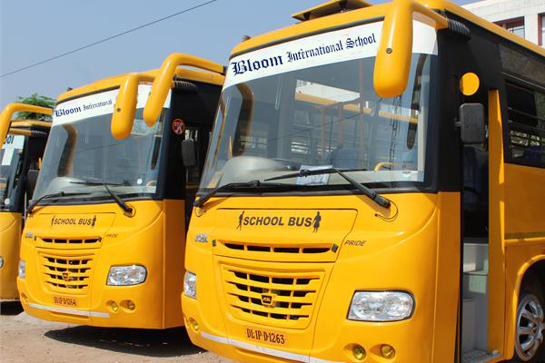

SMART CLASSROOM
Smart Boards : Meet Technology, the presiding member of the BIS classroom. Technology in Education is a buzzword today. We have been successful in bringing technology to our classrooms with the introduction of interactive Whiteboards or Smart Boards. These allow students to interact with the lesson content while allowing teachers to integrate a range of resources with their lessons. Technology can be a great way to enable active learning and can be used to learn on one’s own or to collaborate with others. The classroom transforms into an interactive forum for sharing experiences among students, thus helping in widening their analytical faculties.

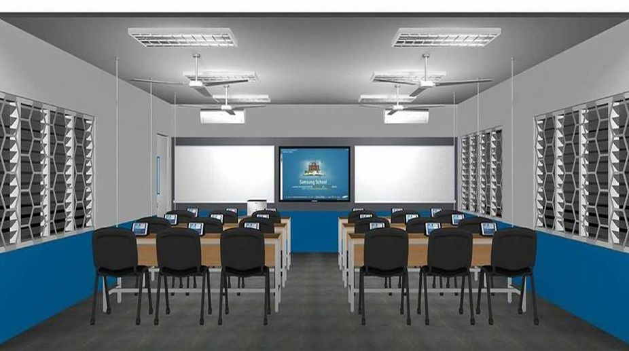
SCHOOL PLAYGROUND
We have lush green grounds for cricket, hockey, football and basket ball. There are also two lawn tennis clay courts, a standard size skating rink and horse riding area, one standard size badminton court, 10 mtr shooting range, one chess room one table tennis room and the MP hall for Karate. In addition we have a fully equipped Gymnasium and an Olympic sized athletic track.

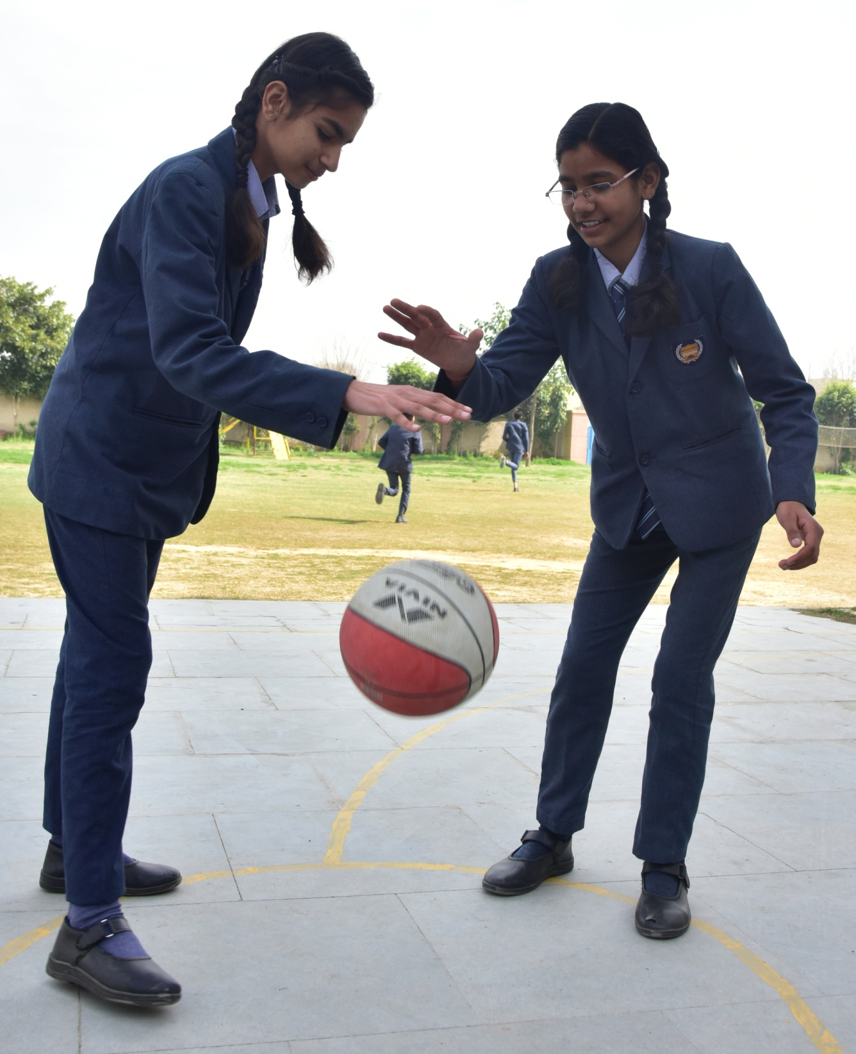

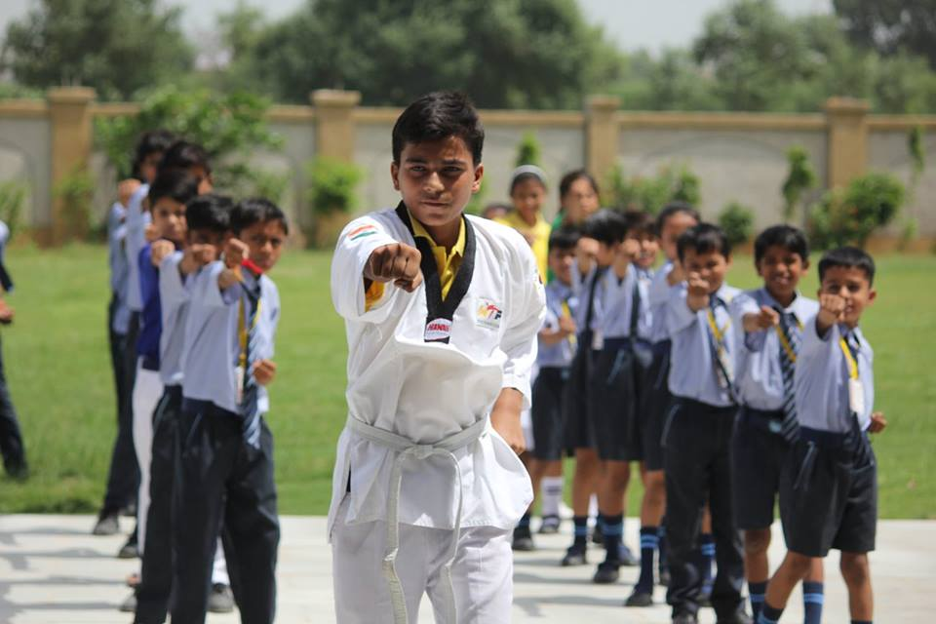

EXTRA CURRICULAR ACTIVITIES
The school imparts good education and side by side provides sufficient opportunities for co- curricular, cultural activities and sports. The school regularly conducts excursions and outings for students and take active part in inter school competitions of the city.

CO-CURRICULAR ACTIVITIES
Co- curricular activities are planned carefully to draw out the talent and the best potential of the students. The school also organizes inter house Debate/ Quiz/ Recitation/ Calligraphy and storytelling competitions.
The importance of sports and games in school encompasses more than just the benefit of physical activity. Increases in self-esteem and mental alertness make school sports and games necessary for every school age child. It teaches the children life skills like teamwork, leadership, patience.
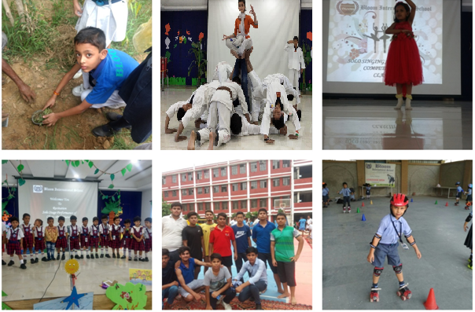v.

School at a Glance
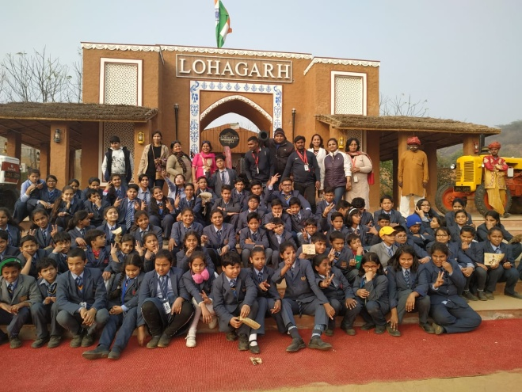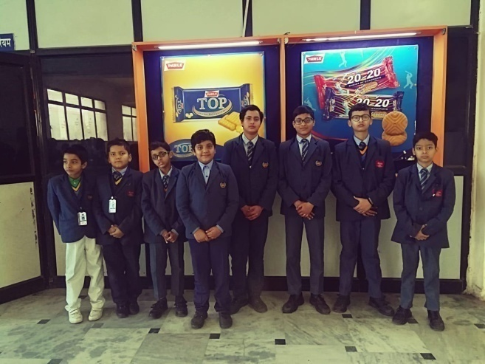
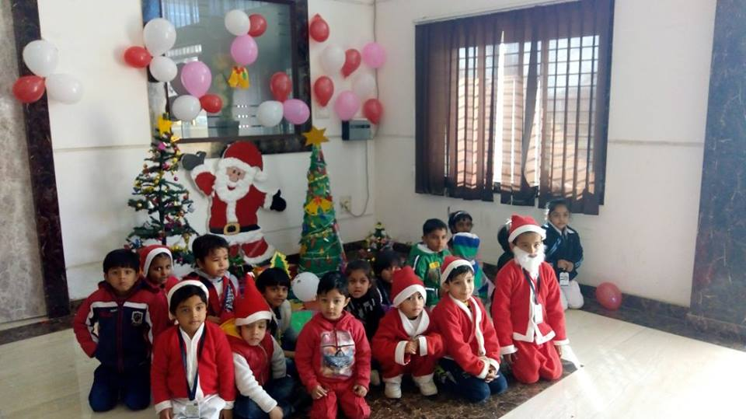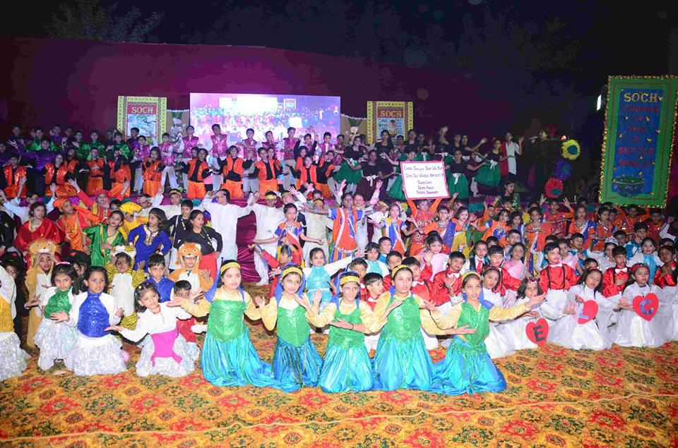
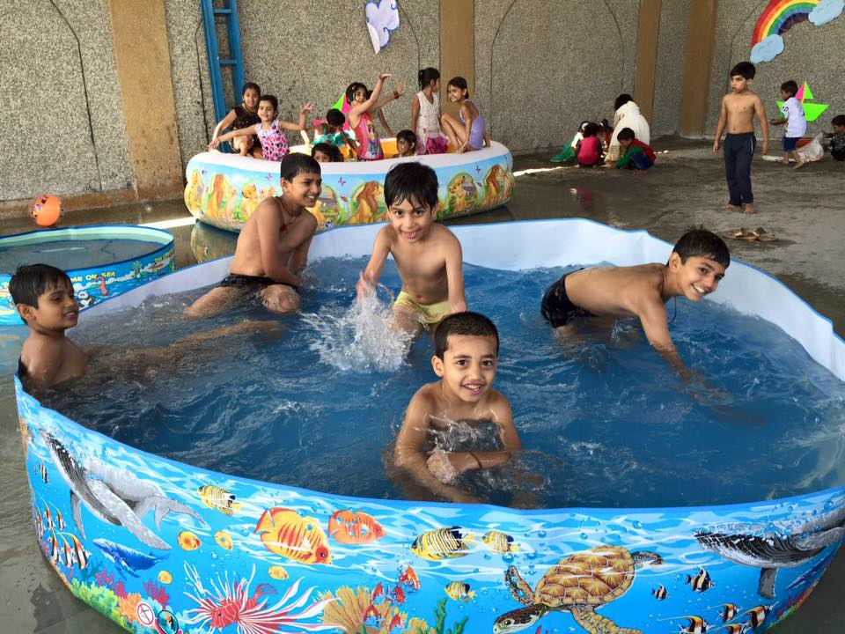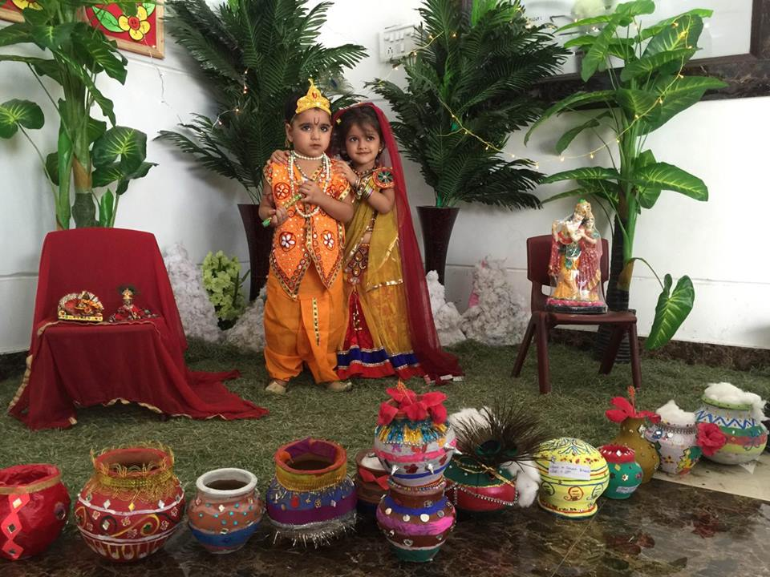
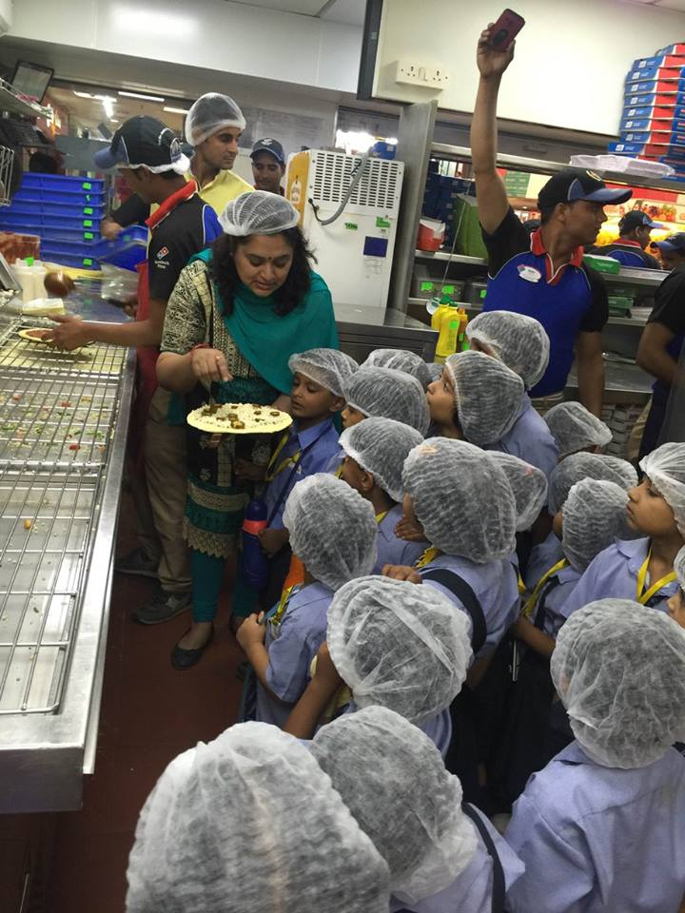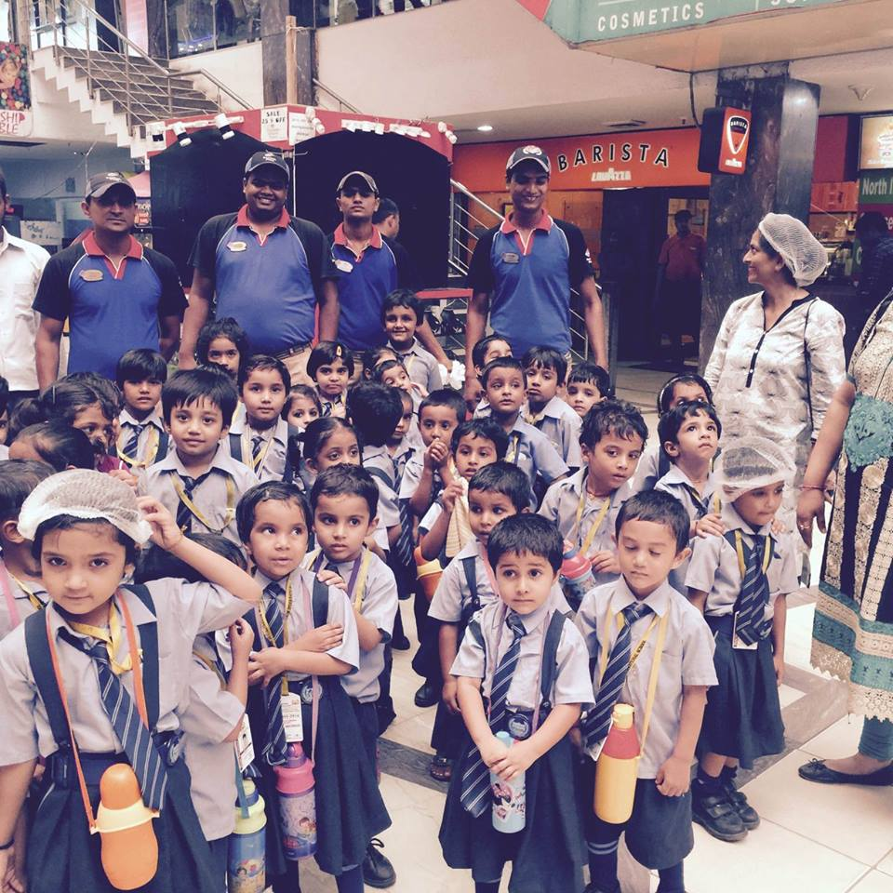
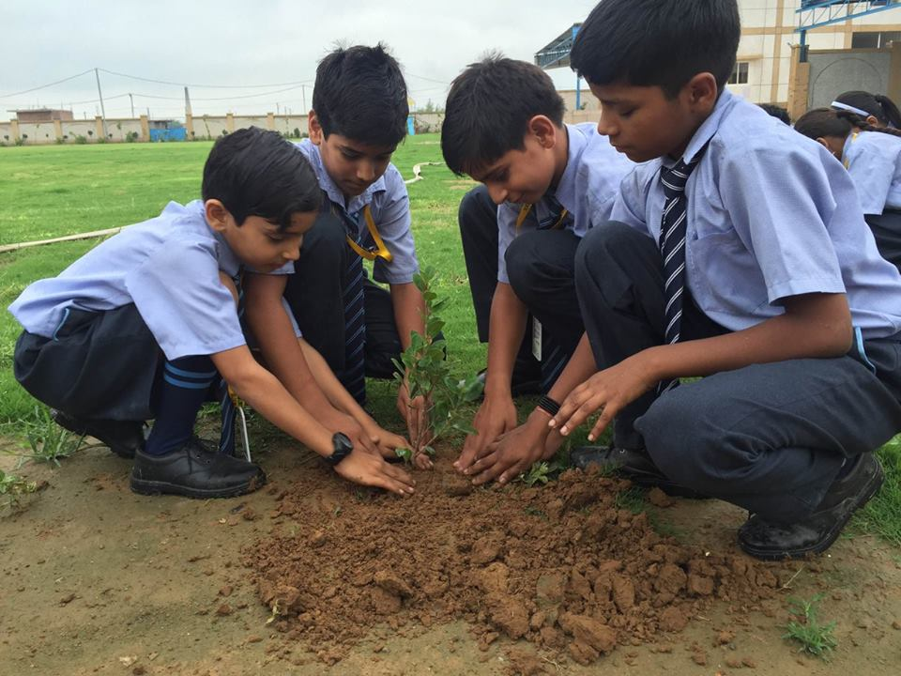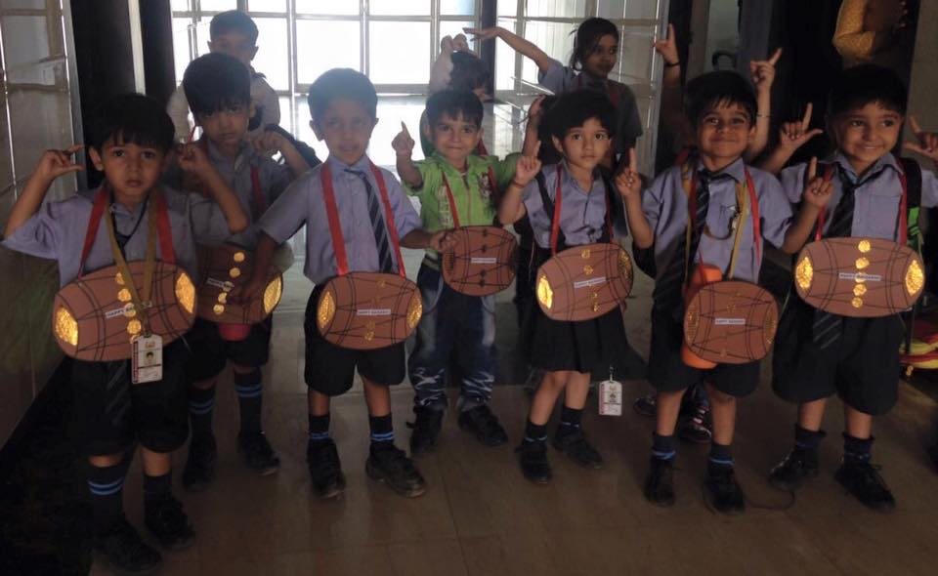

Bloom in News
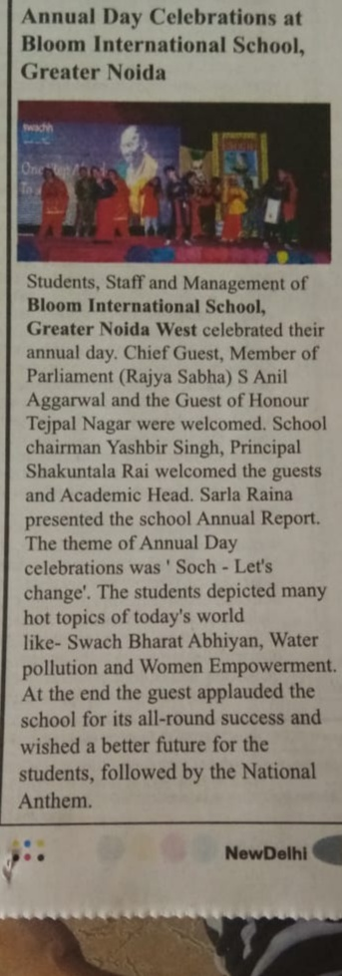 | 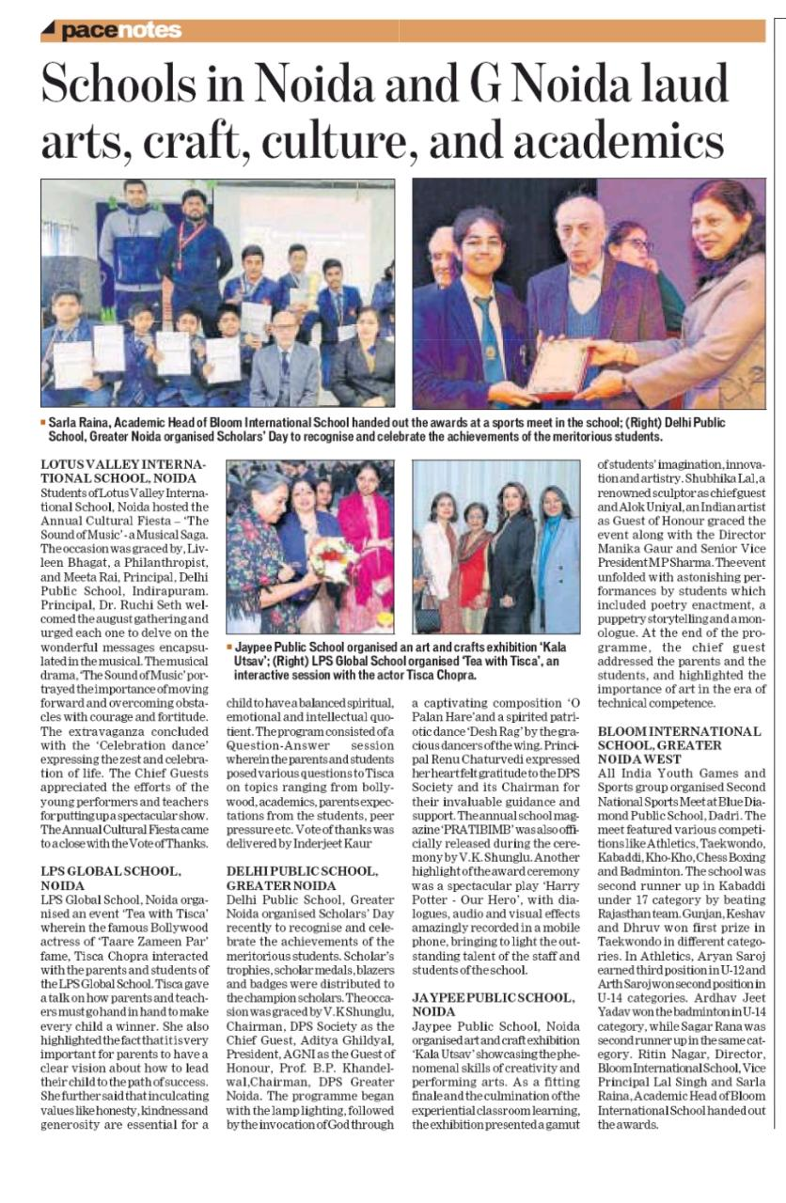
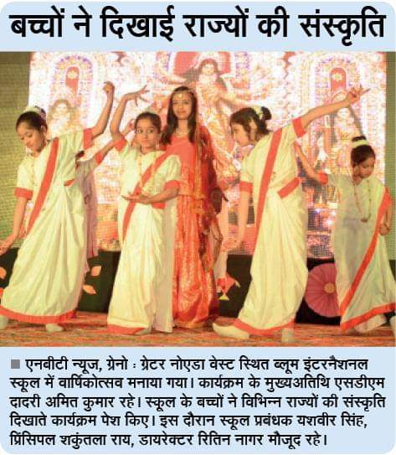 | 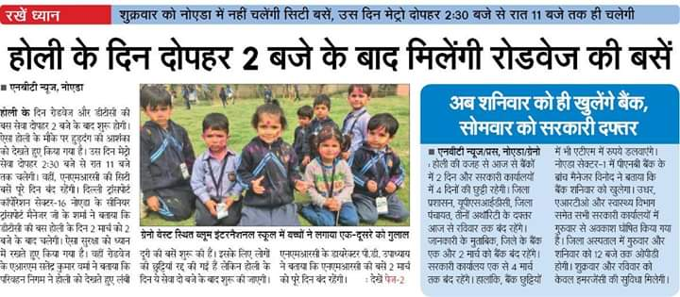
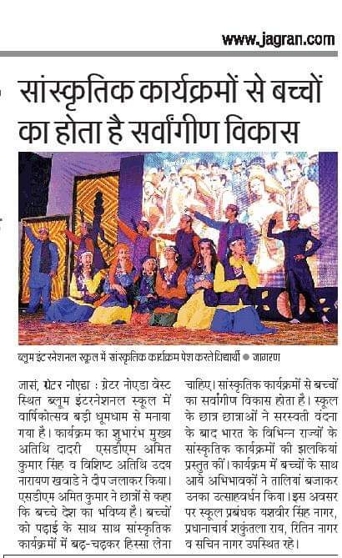

ADMISSION
For admission in Bloom International school you should adopt school values and approach towards education. Preference is given to siblings.
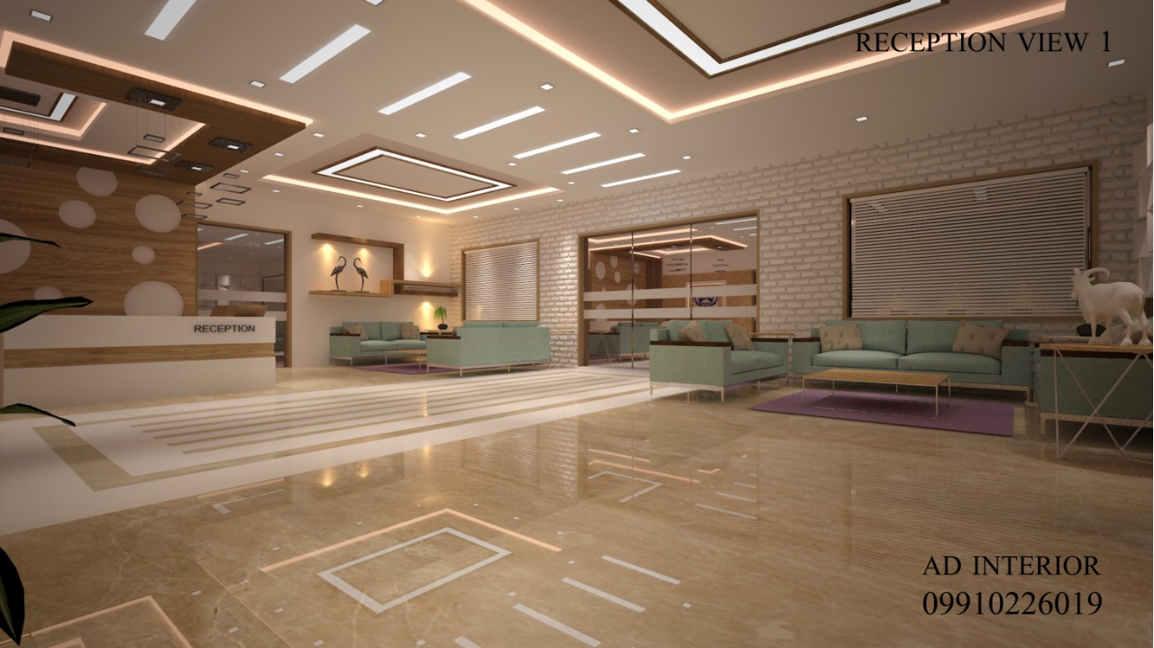
REGISTRATION IN THE SCHOOL STARTS FROM THE MONTH OF DECEMBER ONWARDS.
A written/oral test is conducted to test the basic acumen of the child.
Admission is done on the basis of qualifying exam result ,performance in interview and test.
An admission test will be conducted in the following subjects:
PRIMARY CLASSES- English, Hindi, Mathematics
MIDDLE AND SECONDARY CLASSES- English,Science, Mathematics
Decision of school authorities shall be final and binding.
FOR ADMISSI0N UPTO CLASS IX & XI
Admission to class I to VIII will be subject to the applicants producing following documents.-
Mark Sheet of the last examination passed.
School leaving certificate.
GENERAL RULES OF ADMISSION
The age limit for new admissions is as follows:
- Pre Nursery 2+
- Nursery 3+
- KG 4+
- Class I 5+
Admission will be done after general interview and interaction with the child.
Kindly note that all admitted students are required to submit the following documents:
- Date of Birth certificate from the municipal authority
- 3 photographs of the child
- 2 photographs of Father and Mother each.
- Address proof of the parents.
- Medical certificate of fitness of the child.
- Photocopy of Adhaar card/ Passport
- For higher classes TC from previous school.

FEE STRUCTURE

School Fees is payable Quarterly at the accounts section of the school as per schedule given below
1st Quarter(April,May,June) | By 15th April
2nd Quarter (July,August,September ) | By 15th July
3rd Quarter (October,November,December) | By 15th October
4th Quarter (January,February,March) | By 15th January
- Fee may be deposited from 1st to 15th of the first month of the quarter in which the fees become payable. Thereafter school fee will be accepted with a late fee of Rs. 20 per day . However it will be appreciated if the school fees are paid well in time to avoid late fee penalty.
- Fees acceptance timings 8:00 am to 1:00pm (Monday to Saturday)
- Tuition Fee, admission fee and other charges are subject to revision and will be charged as directed by the school management from time to time.
- If all dues are not cleared by the end of the session, the students result will be withheld.
- Transport charges(as applicable) are payable along with school fee and Transport Facility won’t be discontinued in Mid Session.
- Parents who opt to deposit the fees for the whole term at the beginning of the first quarter will be offered 10% rebate on the total fees.

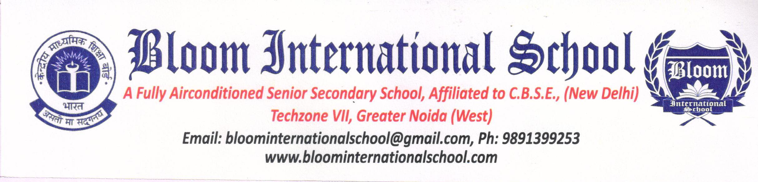
Reg. No. ………………….. REGISTRATION FORM Date . …………….
(Issue of registration form does not imply admission, as seats are limited )
1 . Admission sought to : Class : ……………………………………. Session : 20………….
2. Child’s name (Block Letters):
3. Date of birth ( in figures and in words ) :
D D M M Y Y Y Y
………………………………………………………………………………………………………………………………………………………………….
Age, as on 1 st April 20…………, Years……………Months……………………..Days………………………………………………………
4. Gender : Male Female
5. Nationality of Child : ……………………………………………………………………………………………………………………………..
Mother Tongue : ………………………………………………………………Home Town ………………………………………….
Category : SC/ST/OBC/GEN ……………………………… Blood Group : ……………………………
(If the category is SC,ST or OBC, please submit self attested photocopy of the certificate from the competent authority)
6. Address (Present) : …………………………………………………………………………………………………………………………….
………………………………………………… Pin : …………………………………………………………………
(Permanent) : ……………………………………………………………………………………………………………………………..
…………………………………………………… Pin: ………………………………………………………………….
7. Mother’s Name :
(Block Letters)
Academic Qualification : …………………………………………………………………………………………………………………………….
Occupation :……………………………………………………….. Designation ……………………………………………….
Office Name & Address : …………………………………………………………………………………………………………………………….
Phone : (M)………………………………… (O) …………………………………. (R)…………………………………….
E-mail (Mandatory) :……………………………………………………………………………………………………………………………..
8. Father’s Name
(Block Letters)
Academic Qualification :………………………………………………………………………………………………………………………………..
Occupation :…………………………………………………………. Designation………………………………………………….
Office Name & Address:……………………………………………………………………………………………………………………………………..
Phone : (M)………………………………… (O) …………………………………. (R)………………………………………..
E-mail (Mandatory) :………………………………………………………………………………………………………………………………….
9. Guardian’s Name :
(Block Letters)
Occupation : ………………………………………………………….. Designation……………………………………………….
Relationship with child : ………………………………………………………………………………………………………………………………….
Office Name & Address :…………………………………………………………………………………………………………………………………..
Phone : (M)………………………………… (O) …………………………………. (R)…………………………………………..
10. Details of present school being attended:
- Name : ……………………………………………………………………………………………………………………………………….
- Class :………………………………………………………………………………………………………………………………………...
- Percentage and position obtained in the last examination : ……………………………………………………….
- Proficiency grade in games/co-curricular/outstanding achievements (enclose certificate ,if any)
11.Came to know about Bloom International School From
- Newspaper 2.Hoardings 3. Friends/Relatives 4.Magazines
ENCLOSURES :
1.Attested Photo Copy of Birth Certificate.
2.Attested Photocopy of Report Card/ Marksheet

DECLARATION
i) I certify that I am the bonafide guardian of the child.
ii) I understand that the registration fee is non refundable and that registration does not guarantee admission, Admission is given only when a suitable vacancy exists & the child fulfills all the criteria of admission as per the school norms.
iii) I hereby certify that the date of birth & spelling of the name of my child given in this form are correct to the best of my knowledge and I shall not make any request for changes either later on.
iv) Till the Birth Certificate and Transfer certificate of the child is deposited, his/her admission will be deemed provisional.
v) I understand that rendering false or misleading information or withholding correct information may disqualify the child for admission to this school.
vi) Once admitted, the child will not be entitled to refund of fee deposited ,irrespective of when the child was admitted, in case of the parents wishing to withdraw him/her.
vii) I have made satisfactory arrangement for remittance of school fee within due dates without waiting for a reminder from the school. I will pay the school fee as per rules.
viii) I will furnish complete medical record of the child required by the school medical officer.
ix) I have also understand that as a parents we are expected to check the suitability of the bus route from the published existing routes before seeking admission. Bus facility is optional and school is not bound to provide transport .A Request form for transport has to be submitted separately If will be the sole responsibility of the parent to escort the pupil to and from the respective bus stop.
x) Having read carefully the rules, regulations & procedures laid down in the school prospectus and being desirous of having my child-ward educated in Bloom International School I Hereby agree to abide by them in all respects, I understand that the decision of the management of the school be final and binding on me.
xi) I hereby certify that my ward and I shall follow the rules, regulations & procedures laid down by the school from time to time.
xii) I hereby put my signatures to confirm the above declarations.

Date : …………………………………… Signature of Parent/ Legal Guardian :………………………………....
Place :……………………………………
For Office Use Only
Recommendation of Principal/ Management / Selection Committee :………………………………………………………………….
Principal’s Signature : …………………………………………..
Transfer Certificate received : (Y/N) Admn No. ……………………………… Admn .Date ………………… E. N . No………………. If received , TC No. : …………………………. Date : …………………………………… School : …………………………………………………..

